How to handle frames

Note: if you are getting NoSuchElementException for the right xpath/locator, there is a possibility, that element is in frame. To confirm right click just above or below the element you will see "This Frame" context menu option.

First screenshot explains how web page, frame and indexing start from 0,1,2

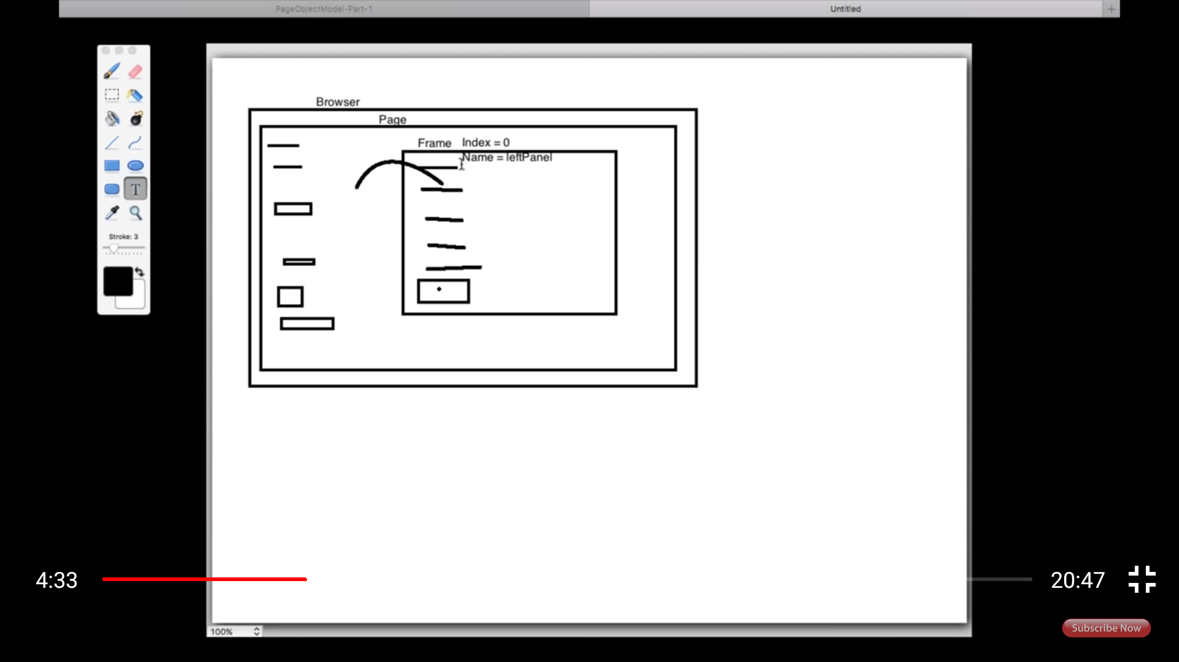

Second and third screenshot showing how frames used in CRM website and it's source code.

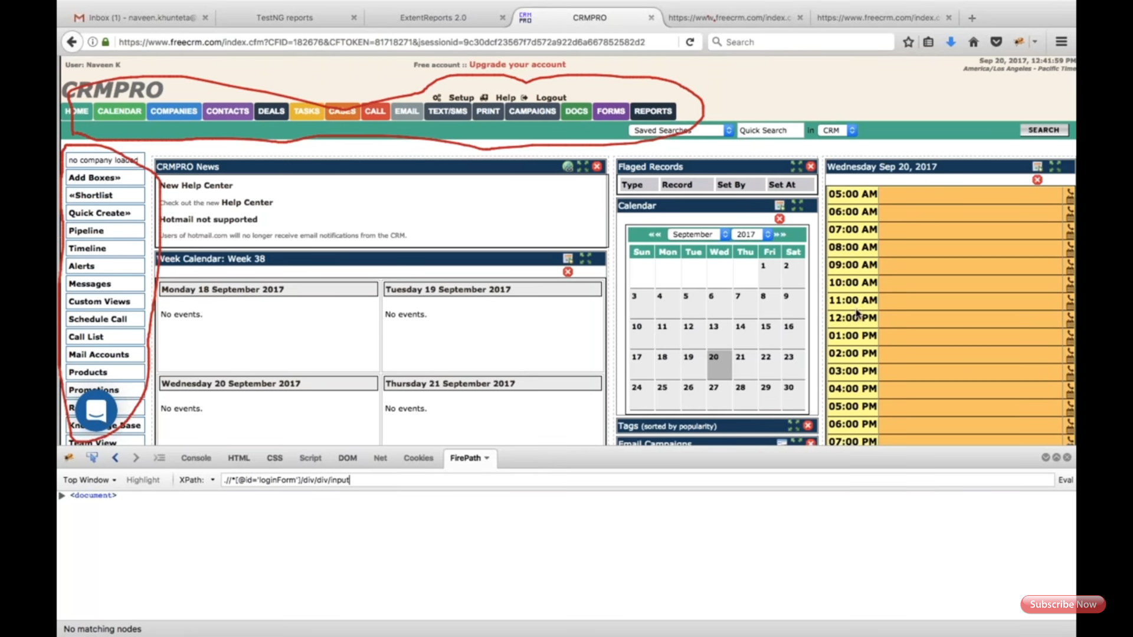

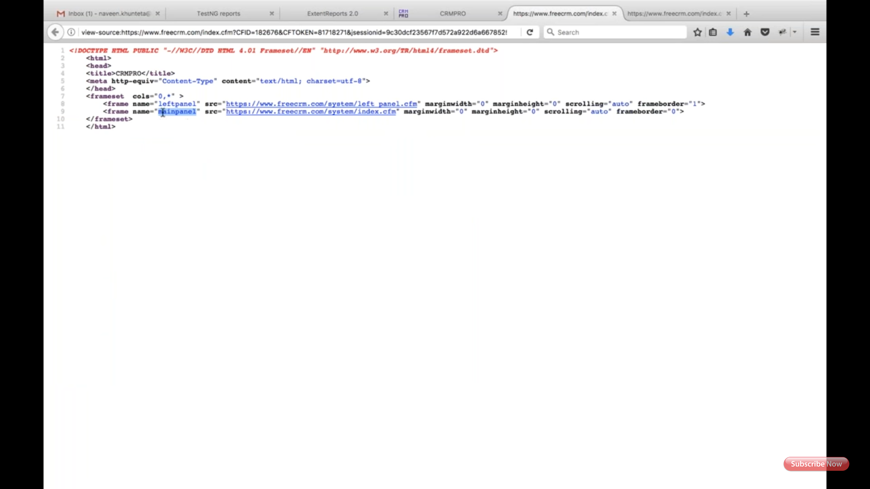

Forth screenshot explains code to handle the frame.

